## The Ant Colony Optimization Algorithm

It is well known that the biological ants in real world are able to utilize swarm intelligence to find the shortest route to nutrients. Ant Colony Optimization (ACO) algorithms have been developed to mimic the behavior of real ants to provide heuristic solutions for optimization problems.

**INSPIRATION**

When searching for food, biological ants exhibit complex social behavior based on the hormones they deposited (called pheromones). Pheromones attract other ants and outline a path to the food source that other ants can follow. As more ants walk along the path, more pheromone is laid, and the chance that more ants will take the path increases. The shortest path to the food builds up the most pheromones because more ants can travel it in less amount of time. To prevent establishing a suboptimal path (when the solution is trapped into a local minimum), the pheromone also evaporates over time [4], thus reducing the change for other ants to take the path. On the other hand, the pheromone levels on the shortest path remain high because in this case, the pheromone deposit speed is faster than its evaporation speed.

**LOGIC:**

Consider a network where ants can travel between different nodes. Using pheromone deposits, the probability that an ant k located in node i will choose to go to another node j in the network is given by:

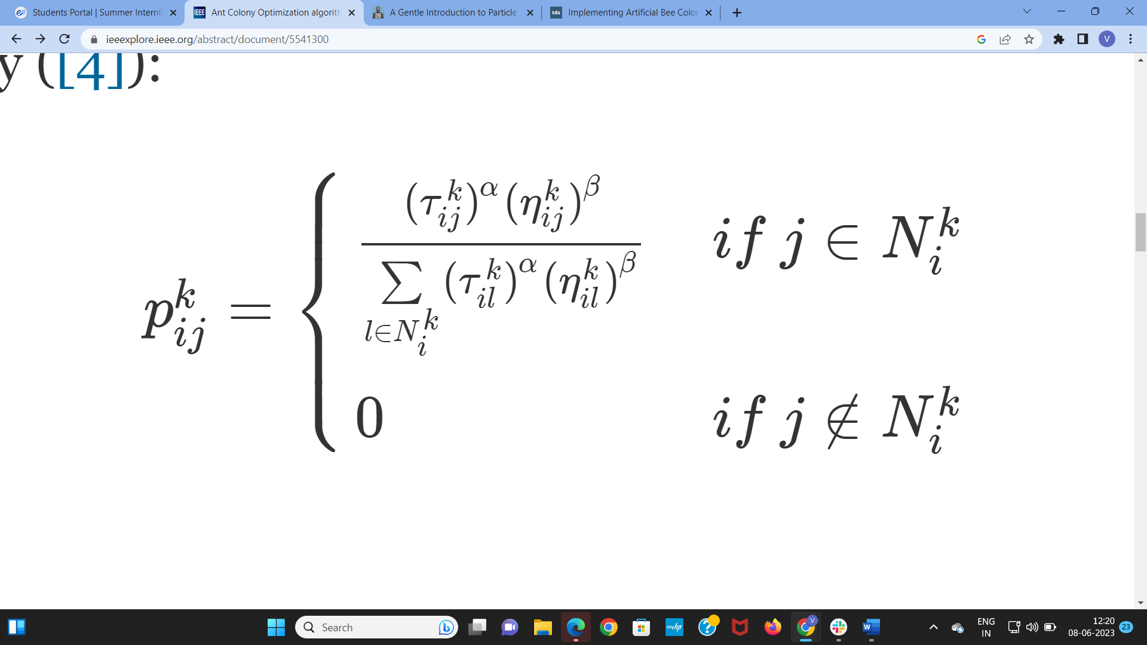

where pheromone levels are denoted by τijk ; as with real ants, the more pheromone on a path, the more possibility that the ant will take the path. The summation in the denominator takes into account all the possible choices (or neighboring nodes) in the set Nik when the ant is at node i. Both α,β, and ηijk are usually application dependent; where ηijk represents the heuristic information, and the values of α and β weigh the importance of the pheromone and heuristic values. When β=0, (ηijk)β=1, then the probability only depends on the pheromone levels; on the other hand, when α=0, the probability only depends on heuristic values - that is, the node that is the closest one to the current node has the highest probability of being selected.

The pheromone levels of the path (from node i to j), can evaporate with a percentage ρ (also called the evaporation rate):

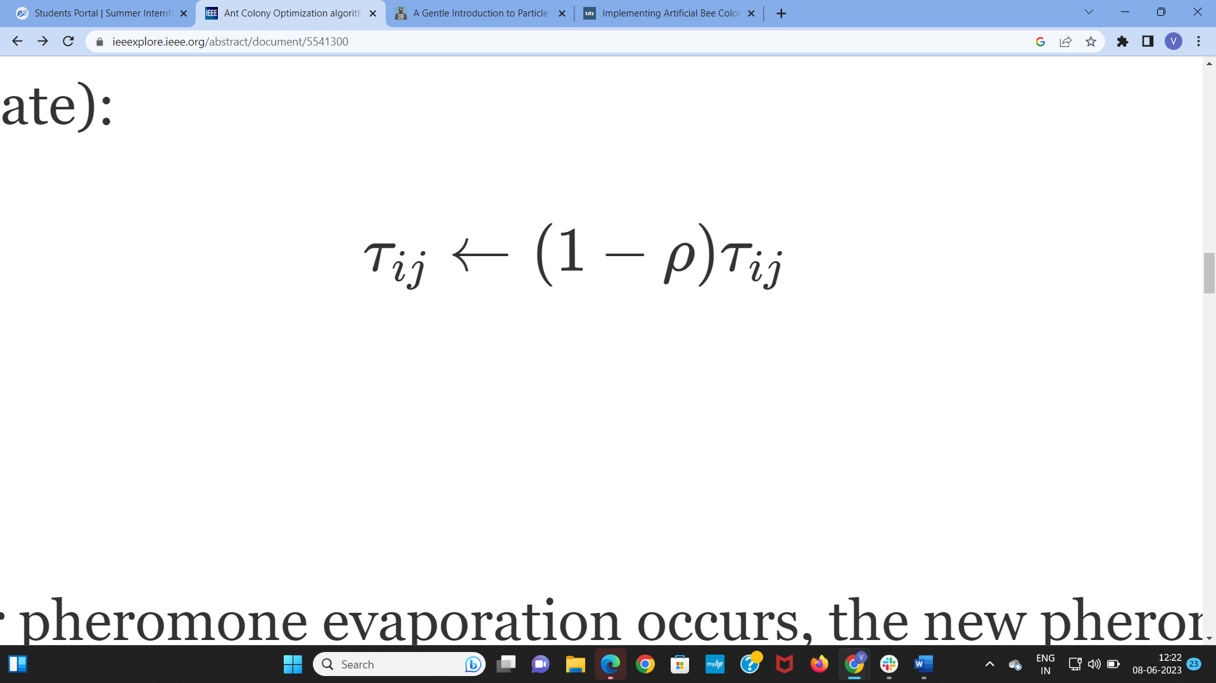

where 0≤ρ<1. After pheromone evaporation occurs, the new pheromone levels are updated with the additional pheromone laid by the ant(s) that just crossed the path:

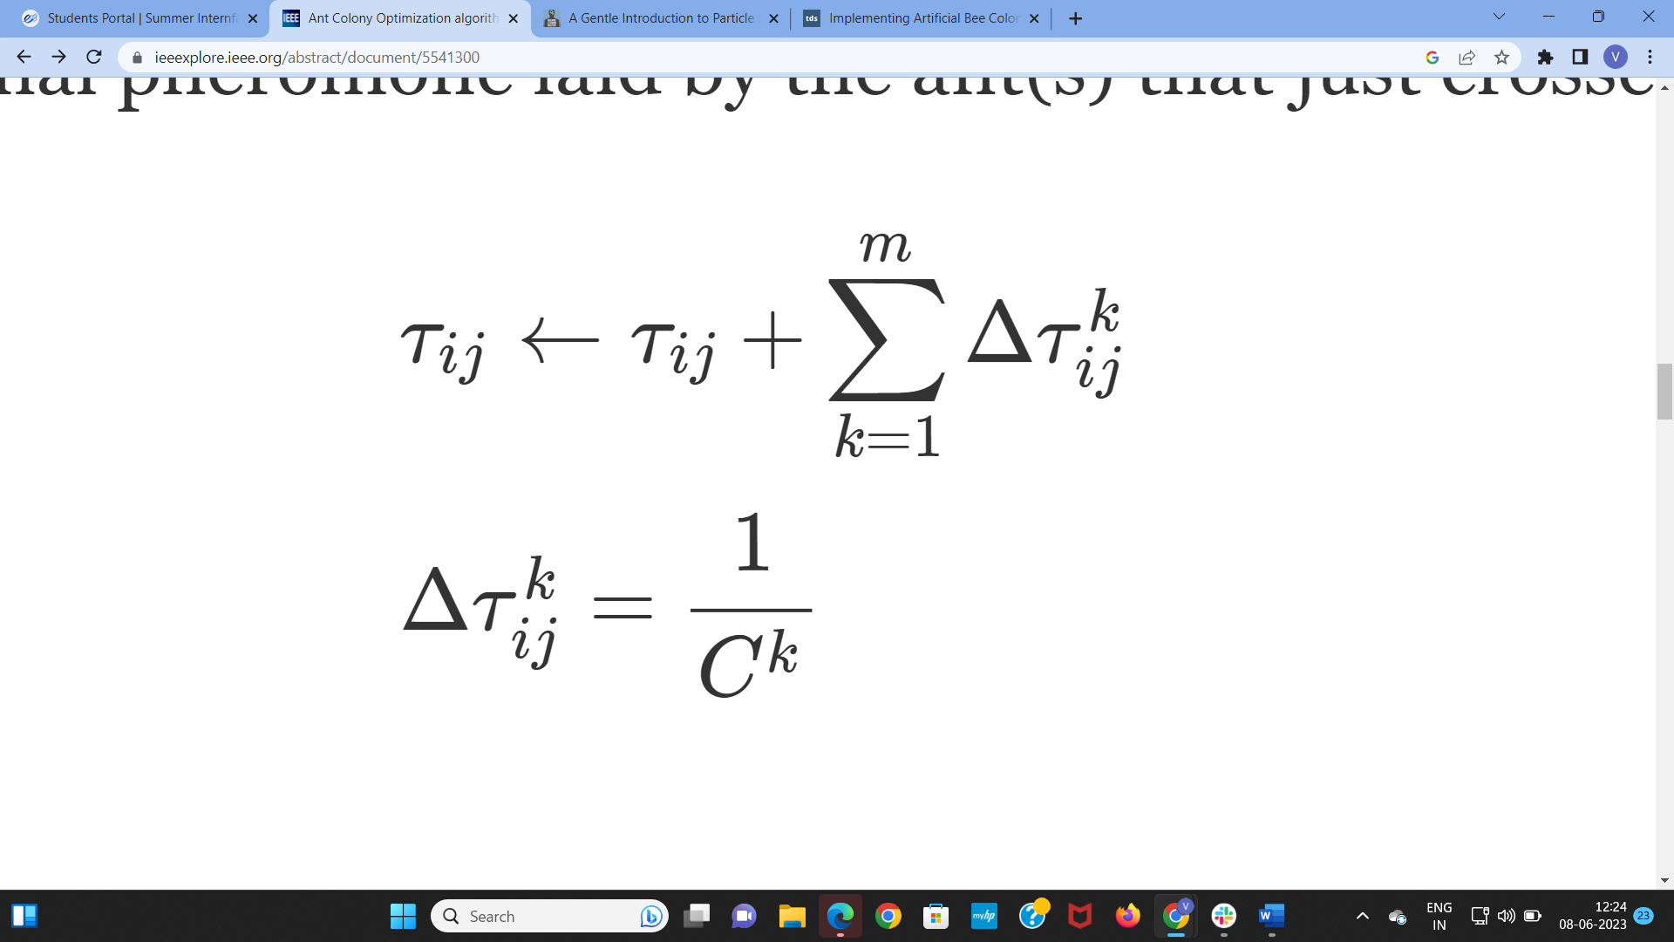

where Ck is the associated cost or reward of ant k for choosing this path.

**PSUEDO CODE:**

Procedure ACO:

Initialize the necessary parameters and pheromone concentration;

while not termination do:

Generate initial ant population;

Calculate the fitness values for each ant of the colony;

Find optimal solution using selection methods;

Update pheromone concentration;

end while

end procedure

COMPUTATIONAL FLOWCHART OF ACO:

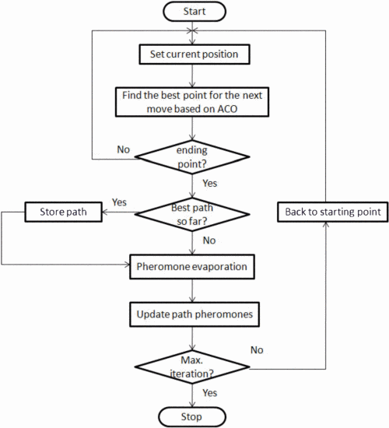

FLOW CHART OF ACO WITH OBSTACLES:

